AI ASSISTED CODING
ASSIGNMENT-10.4

2403A51274-Swamy
BATCH-12
Task 1: Syntax and Error Detection
Task: Identify and fix syntax, indentation, and variable errors in the
given script.
# buggy_code_task1.py
def add_numbers(a, b)
result = a + b
return reslt
print(add_numbers(10 20))
Expected Output:
• Corrected code with proper syntax (: after function, fixed variable
name, corrected function call).
• AI should explain what was fixed.

PROMPT:
TASK: Fix the syntax errors, indentation, and variable names in the code below.
The corrected function should return the sum of two numbers. Also correct the function call to print the result of adding 10 and 20.

CODE AND THE OUTPUT:
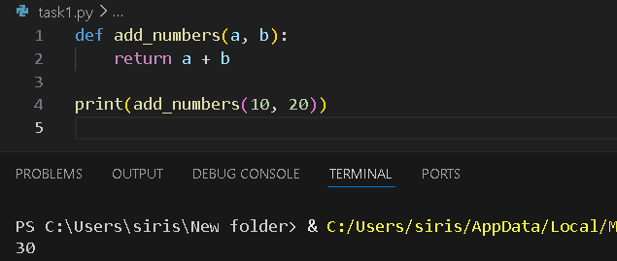

Task 2: Logical and Performance Issue Review.
Task: Optimize inefficient logic while keeping the result correct.
# buggy_code_task2.py
def find_duplicates(nums):
duplicates = []
for i in range(len(nums)):
for j in range(len(nums)):
if i != j and nums[i] == nums[j] and nums[i] not in duplicates:
duplicates.append(nums[i])
return duplicates
numbers = [1,2,3,2,4,5,1,6,1,2]
print(find_duplicates(numbers))
Expected Output:
• More efficient duplicate detection (e.g., using sets).
• AI should explain the optimization.

PROMPT:
TASK: Optimize the find_duplicates function below.
Requirements:
- Return the same duplicates as before
- Use sets or other efficient logic to improve performance to O(n)
- Keep output as a list of duplicates.

Buggy code:
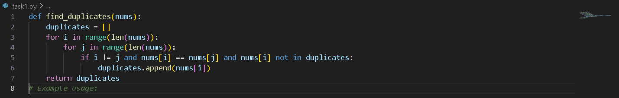

Corrected code:
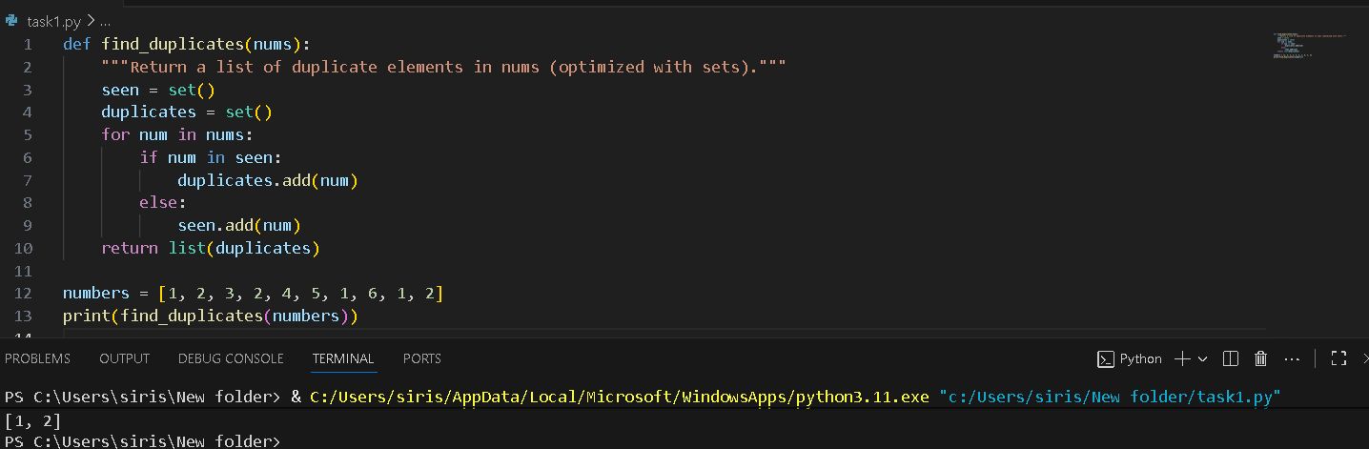
Task 3: Code Refactoring for Readability
Task: Refactor messy code into clean, PEP 8–compliant, well-
structured code.
# buggy_code_task3.py
def c(n):
x=1
for i in range(1,n+1):
x=x*i
return x
print(c(5))
Expected Output:
Function renamed to calculate_factorial.
Proper indentation, variable naming, docstrings, and formatting.
AI should provide a more readable version

prompt:
TASK: Refactor the factorial function below for readability:
- Rename function to calculate_factorial
- Follow PEP 8 formatting and indentation
- Use descriptive variable names
- Add a Google-style docstring and type hints
- Include error handling for negative input.

Messy code:
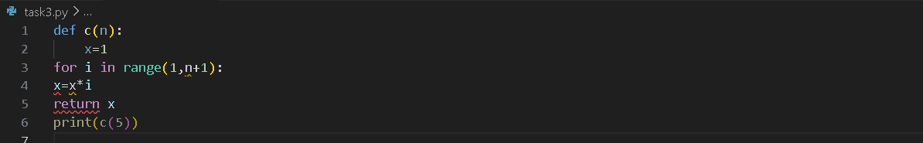

Corrected code:
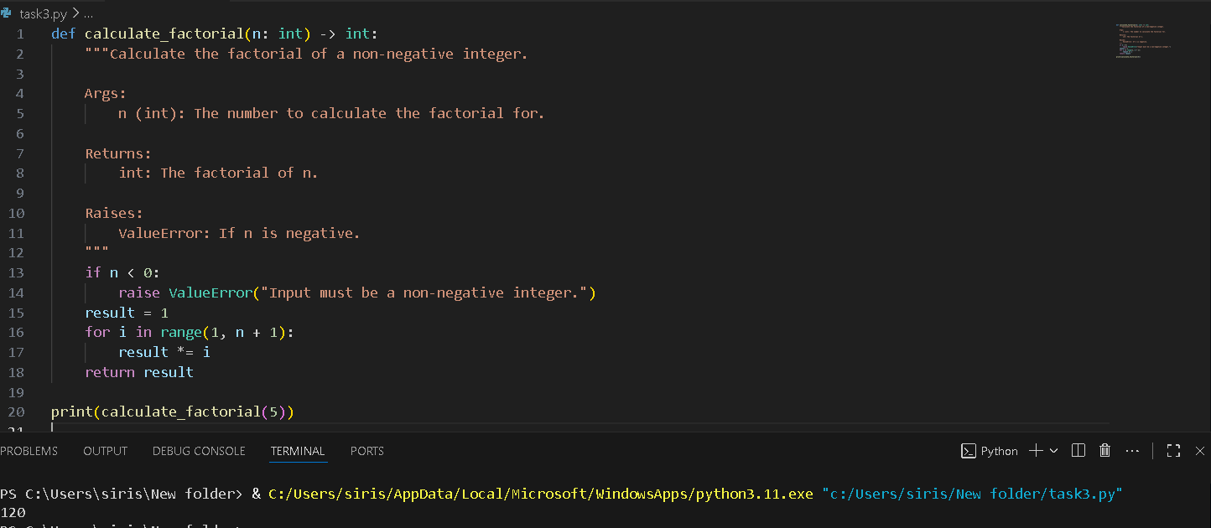

Task 4: Security and Error Handling Enhancement
Task: Add security practices and exception handling to the code.
# buggy_code_task4.py
import sqlite3
def get_user_data(user_id):
conn = sqlite3.connect("users.db")
cursor = conn.cursor()
query = f"SELECT * FROM users WHERE id = {user_id};" #
Potential SQL injection risk
cursor.execute(query)
result = cursor.fetchall()
conn.close()
return result
user_input = input("Enter user ID: ")
print(get_user_data(user_input))
Expected Output:
Safe query using parameterized SQL (? placeholders).
Try-except block for database errors.
Input validation before query execution.

Prompt:
TASK: Enhance security and error handling in the function below:
- Use parameterized SQL instead of f-strings to prevent injection
- Add try/except/finally for database connection and errors
- Validate that user input is an integer before executing the query
- Use clear function and variable names, plus docstrings.

Messy code:
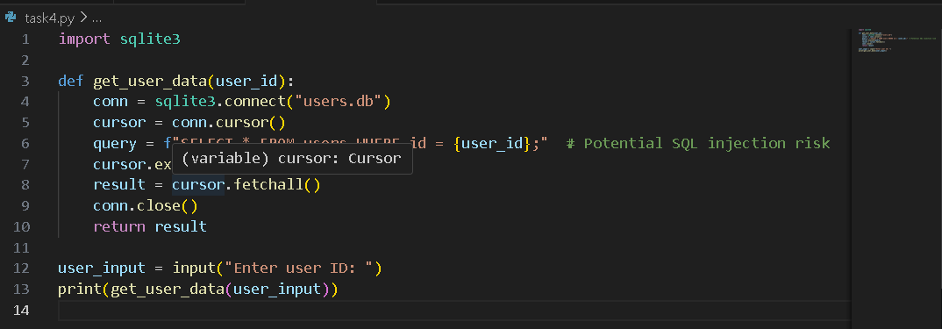

Problems with messy code:
- SQL injection risk — f-string directly inserting user_id.
- No input validation — user_id might not be an integer.
- No exception handling — DB errors could crash the program.

Updated code:
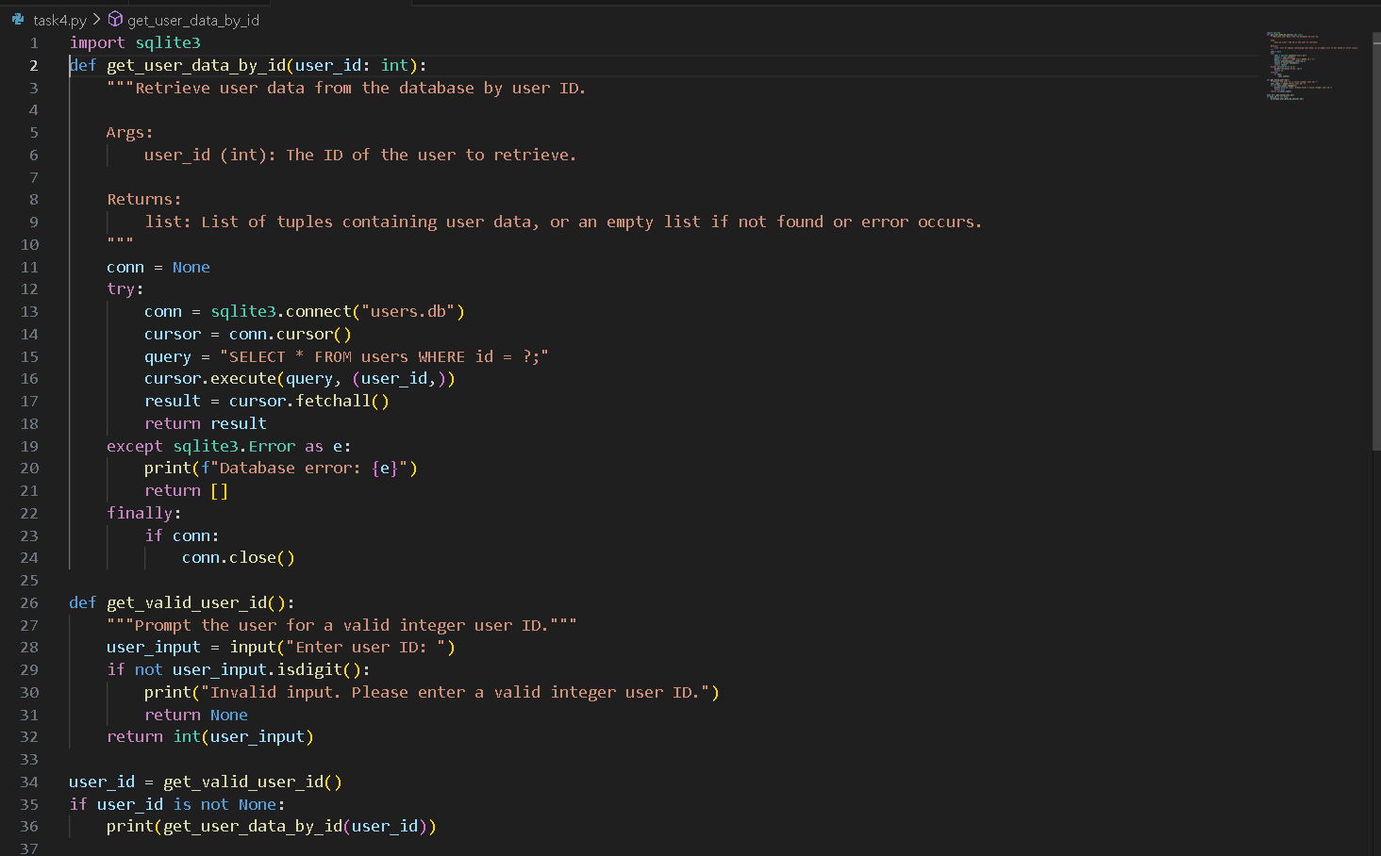
Task 5: Automated Code Review Report Generation
Task: Generate a review report for this messy code.
# buggy_code_task5.py
def calc(x,y,z):
if z=="add":
return x+y
elif z=="sub": return x-y
elif z=="mul":
return x*y
elif z=="div":
return x/y
else: print("wrong")
print(calc(10,5,"add"))
print(calc(10,0,"div"))
Expected Output:
AI-generated review report should mention:
o Missing docstrings
o Inconsistent formatting (indentation, inline return)
o Missing error handling for division by zero
o Non-descriptive function/variable names
o Suggestions for readability and PEP 8 compliance

prompt:
TASK: Perform an automated code review of the following function.
- Identify missing docstrings
- Identify inconsistent formatting and indentation
- Identify missing error handling (like division by zero)
- Identify non-descriptive names
- Suggest improvements for readability and PEP 8 compliance.

Messy code:
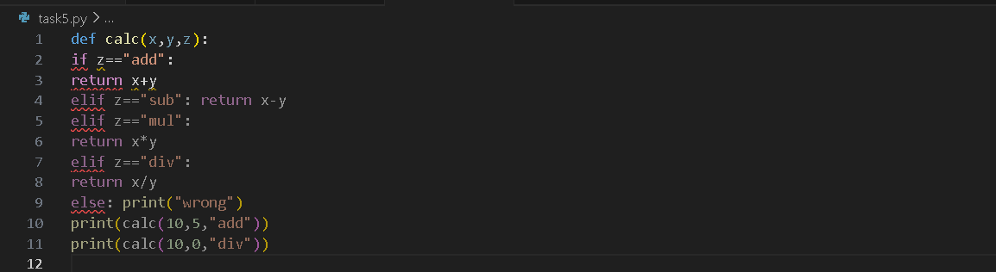

Updated code:
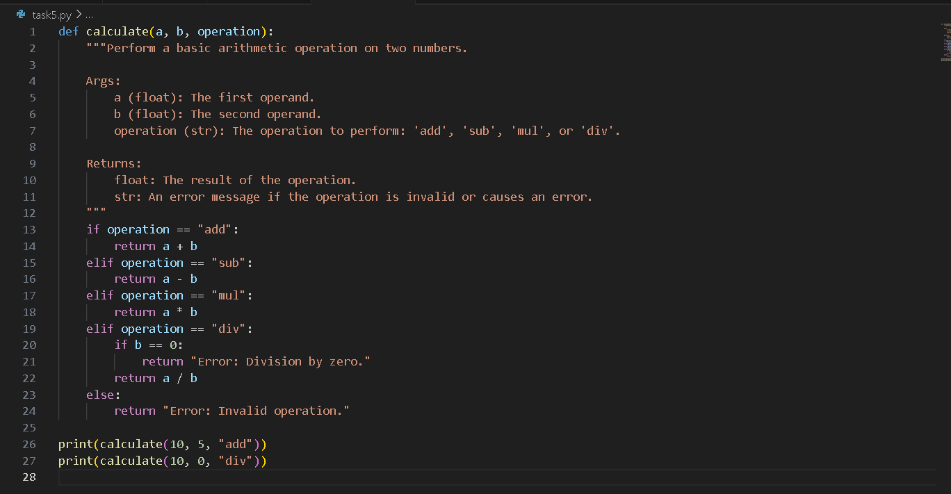

Report:
- Missing Docstrings
  - The function calc lacks a docstring explaining its purpose, parameters, and return value.
- Inconsistent Formatting and Indentation
  - The function body is not properly indented.
  - The elif and else statements are not consistently formatted.
  - The print statements are not separated from the function definition.
- Missing Error Handling
  - Division by zero is not handled, which will raise a ZeroDivisionError if y is zero and z is "div".
- Non-descriptive Names
  - The function name calc and parameter names x, y, and z are not descriptive. More meaningful names like a, b, and operation would improve readability.
- Other Suggestions
  - Use return instead of print for error messages to keep function output consistent.
  - Consider using a dictionary to map operations to functions for scalability.
  - Follow PEP 8: add spaces after commas, use lowercase with underscores for function names, and add two blank lines before function definitions.
Suggested Improvements
- Add a docstring.
- Use descriptive parameter names.
- Properly indent the function.
- Add error handling for division by zero.
- Use PEP 8 formatting.
- Return error messages instead of printing them inside the function.

